

|  |  |
| --- | --- |
| **Version No.** | 1.0 |
| **Date** | 14th Feb, 2018 |

Copyright

*This document is confidential to EY India. This document contains information and data that EY considers confidential and proprietary (“Confidential Information”).*

*Any disclosure of Confidential Information to, or use of it by a third party, will be damaging to EY. Ownership of all Confidential Information, no matter in what media it resides, remains with EY.*

Document release notice

Revision History

|  |  |  |  |
| --- | --- | --- | --- |
| Version | Date (Issued for Review) | Description (Changes Made) | Author |
| 1.0 | 15-02-2018 |  | Deepak and Sachindra |
|  |  |  |  |
|  |  |  |  |
|  |  |  |  |
|  |  |  |  |
|  |  |  |  |
|  |  |  |  |
|  |  |  |  |
|  |  |  |  |
|  |  |  |  |
|  |  |  |  |

Table of Contents

1 EY DevOps Practice 5

2 Dev/ QA Deployment 6

2.1 Login to Jenkins using your credentials 6

2.2 Deployment steps 7

2.3 Common Service Pipelines 8

2.4 ASP_APP Deployment 9

3 UAT Deployment 10

3.1 Dependent Services 10

3.2 Deployment Pipelines. 11

3.3 Implementation 13

4 PROD Deployment 14

5 LogLevel Change in UAT 15

6 Storm Log Level Change 16

# EY DevOps Practice

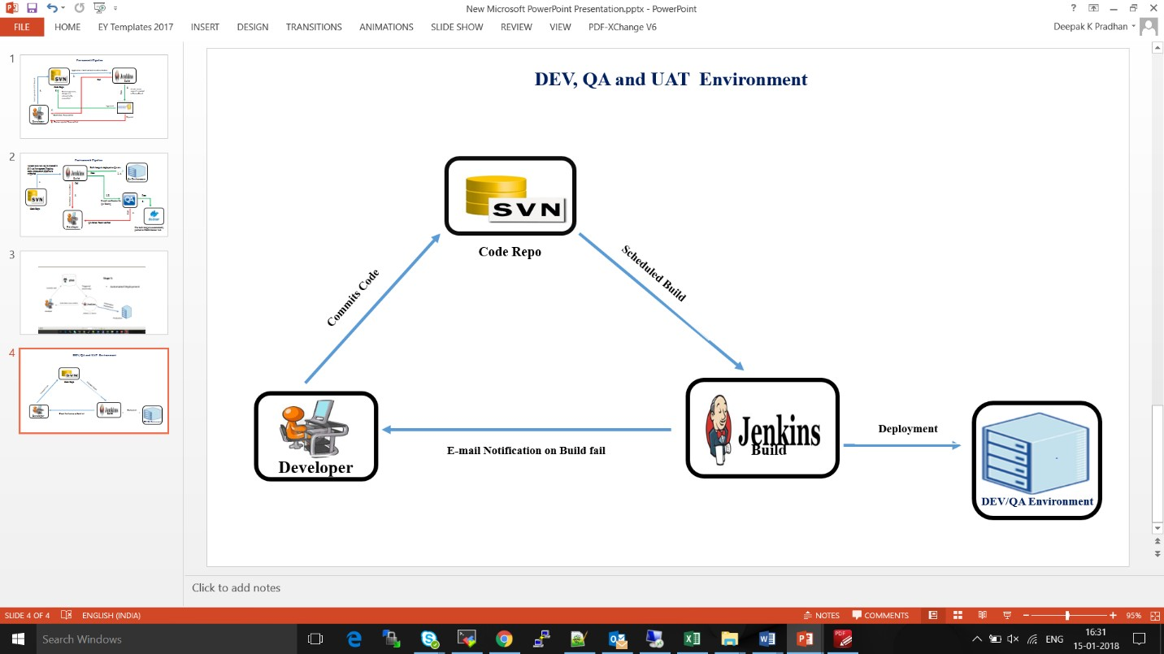

Server details:-

1. Jenkins – ci-sh-sv001
2. Sonar
3. Nexus
4. SVN

# SVN Merge

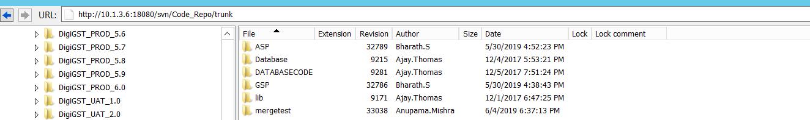

* First, we will check out the code from trunk branch.
* We will take the Revision Graph, as per below screenshot,

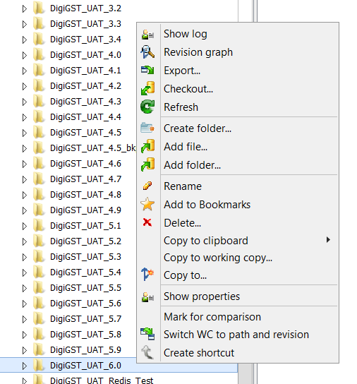

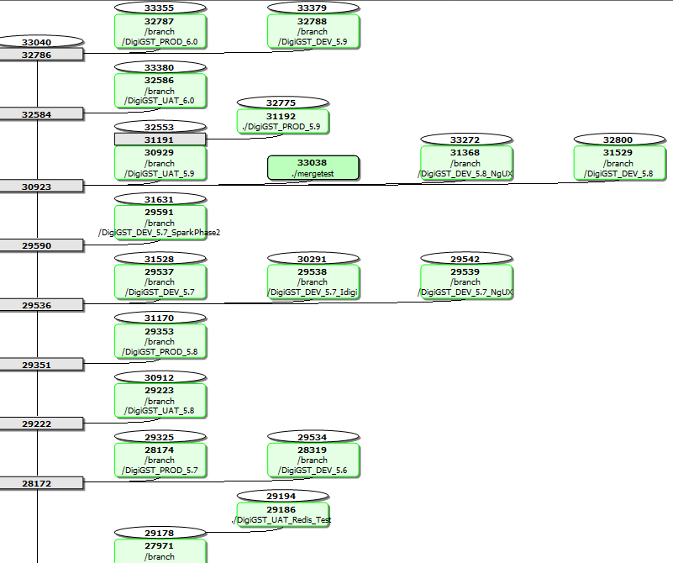

For example, if we want to create new branch say PROD 6.1, we will be merging PROD 6.0 to trunk, UAT 6.0 to trunk and DEV 5.9 to trunk, as per requirement.

PFB the screenshot,

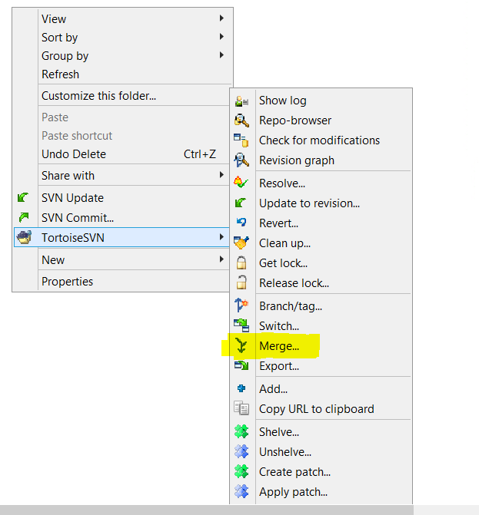

After you have selected the option, next option will take you to below screenshot, where you will be selecting the highlighted option.

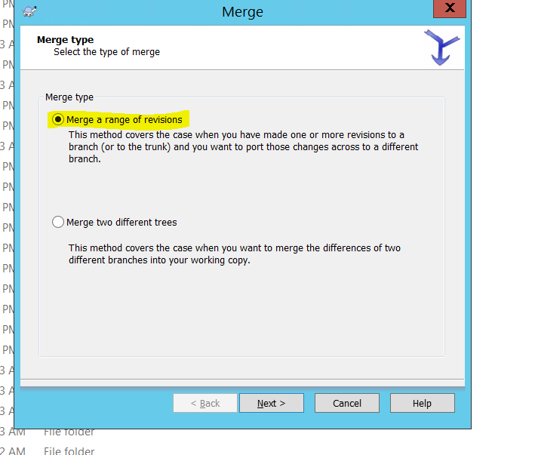

Then clicking on Next, will again take you to another set of options where ‘**URL to merge from’** you need to provide the branch with which you to merge the trunk code, then will select specific range from Revisions

